MỘT SỐ ĐỒ THỊ MẪU DÙNG ĐỂ TEST

## Test 1

6

0 1 1 0 0 0

1 0 1 1 1 0

1 1 0 1 1 0

0 1 1 0 1 1

0 1 1 1 0 1

0 0 0 1 1 0

## Test 2

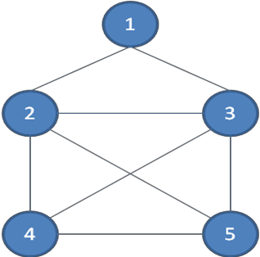5

0 1 1 0 0

1 0 1 1 1

1 1 0 1 1

0 1 1 0 1

0 1 1 1 0

## Test 3

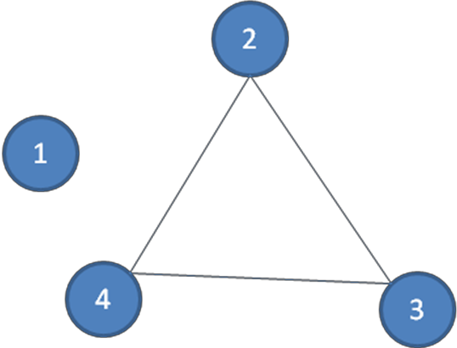

4

0 0 0 0

0 0 1 1

0 1 0 1

0 1 1 0

## Test 4

6

0 0 0 0 1 1

0 0 1 1 0 0

0 1 0 1 0 0

0 1 1 0 0 0

1 0 0 0 0 1

1 0 0 0 1 0

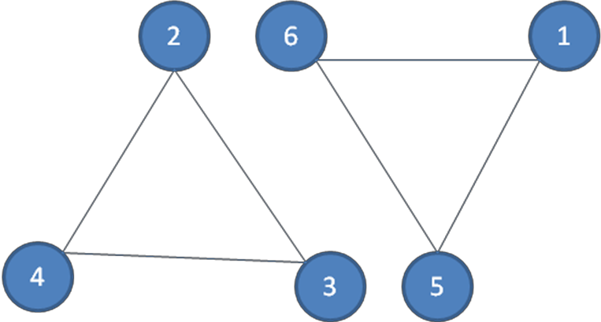

## Test 5

8

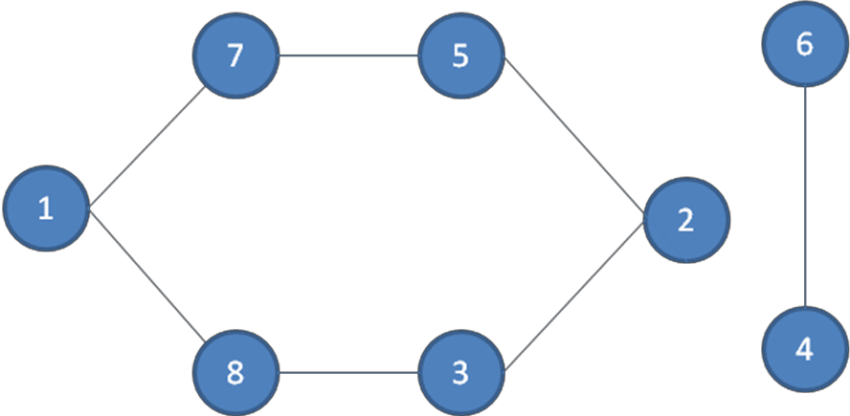0 0 0 0 0 0 1 1

0 0 1 0 1 0 0 0

0 1 0 0 0 0 0 1

0 0 0 0 0 1 0 0

0 1 0 0 0 0 1 0

0 0 0 1 0 0 0 0

1 0 0 0 1 0 0 0

## Test 6

8

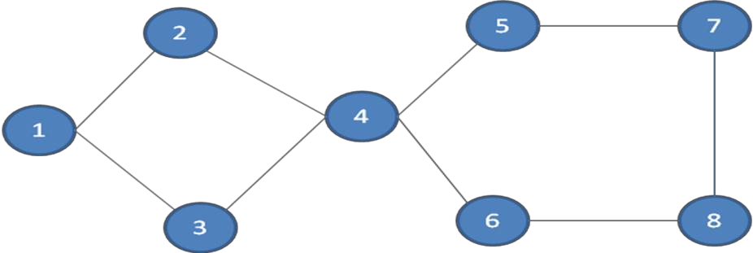0 1 1 0 0 0 0 0

1 0 0 1 0 0 0 0

1 0 0 1 0 0 0 0

0 1 1 0 1 1 0 0

0 0 0 1 0 0 1 0

0 0 0 1 0 0 0 1

0 0 0 0 1 0 0 1

0 0 0 0 0 1 1 0

## Test 7

8

0 1 0 0 0 0 0 0

1 0 0 1 0 0 0 0

0 0 0 1 0 0 0 0

0 1 1 0 1 1 0 0

0 0 0 1 0 0 1 0

0 0 0 1 0 0 0 1

0 0 0 0 1 0 0 1

0 0 0 0 0 1 1 0

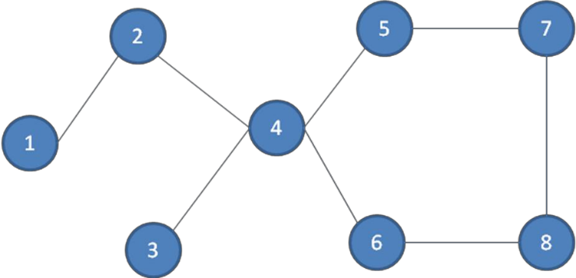

## Test 8

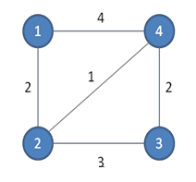4

0 2 0 4

2 0 3 1

0 3 0 2

4 1 2 0

## Test 9

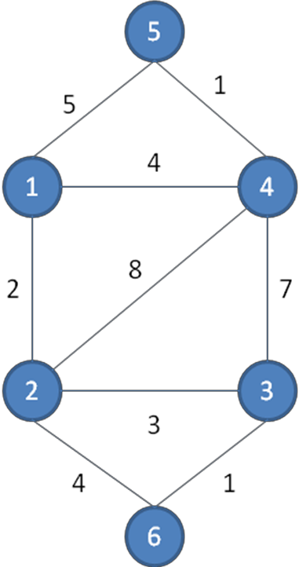

6

0 2 0 4 5 0

2 0 3 8 0 4

0 3 0 7 0 1

4 8 7 0 1 0

5 0 0 1 0 0

0 4 1 0 0 0

## Test 10

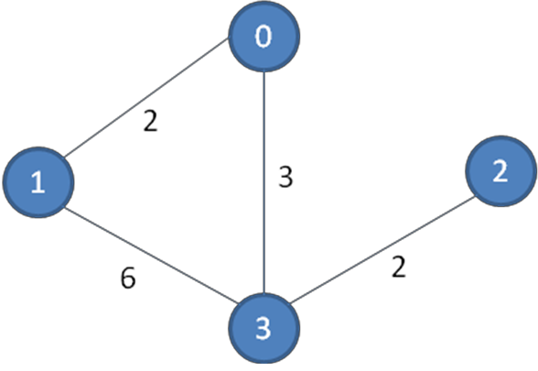4

0 2 0 3

2 0 0 6

0 0 0 2

3 6 2 0

## Test 11

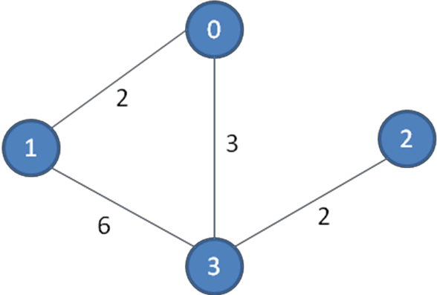5

0 2 0 3 0

2 0 0 6 0

0 0 0 2 0

3 6 2 0 0

0 0 0 0 0